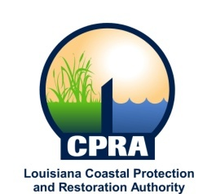

2014 Public Meetings

Garrett Graves, Chairman of the Coastal Protection and Restoration Authority, and Executive Assistant to Governor Bobby Jindal for Coastal Activities has announced the public meetings schedule for the Coastal Protection and Restoration Authority and the Governor’s Advisory Commission on Coastal Protection, Restoration and Conservation. Details on each meeting will be sent out at a later date. The dates and locations of these meetings are subject to change

CPRA
January 15, 2014
Baton Rouge, LA

February 26, 2014
Baton Rouge, LA

March 26, 2014
Houma, LA

April 16, 2014
Baton Rouge, LA

May 21, 2014
Baton Rouge, LA

June 18, 2014
Thibodaux, LA

July 16, 2014
Buras, LA

August 20, 2014
Baton Rouge, LA

September 17, 2014
Lake Charles, LA

October 15, 2014
Baton Rouge, LA

November 12, 2014
Baton Rouge, LA

Governor’s Advisory Commission
February 5, 2014
New Orleans

April 2, 2014
Baton Rouge, LA

June 4, 2014
Baton Rouge, LA

August 6, 2014
Lake Charles, LA

October 9, 2014
Chauvin, LA

December 3, 2014
New Orleans, LA

